20.14: a) From Eq. (20.13), the rejected heat is 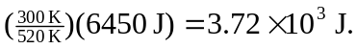
b)
c) From either Eq. (20.4) or Eq. (20.14), e=0.423=42.3%.

